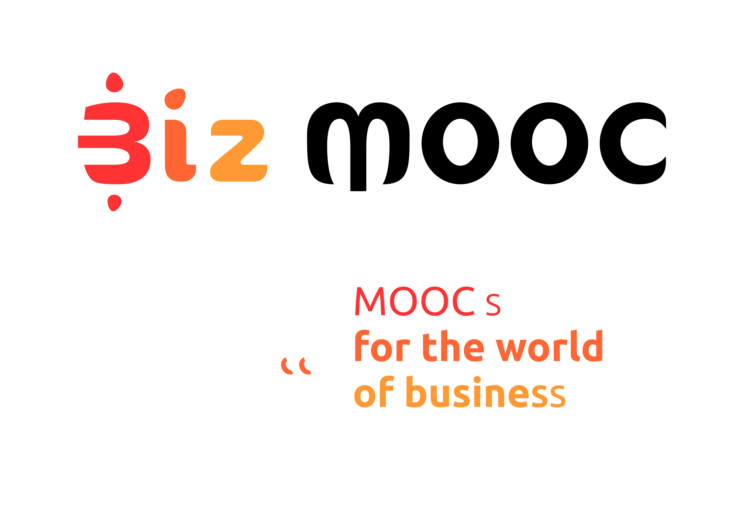
08
Fall

BizMOOC Ressources
Pre-Course Survey MOOC Participants
  - Pre-Course Survey MOOC Participants

BizMOOC Ressources
Pre-Course Survey MOOC Participants

BizMOOC - BizMOOC - Knowledge Alliance to enable a European-wide exploitation of the potential of MOOCs for the world of business
Programme: Erasmus+ | Key Action 2 | Knowledge Alliances
Reference Number: 562286-EPP-1-2015-1-AT-EPPKA2-KA
Grant agreement number: 2015-2929 / 001-001
Project Duration: 36 months, 1/1/2016 – 31/12/2018

www.mooc-book.eu
www.bizmooc.eu

In this document, we highlight potential questions to be asked in a pre-course survey to MOOC participants which is adressed at professional lifelong learners (“the world of business”). We have created them for the BizMOOC project. There are general questions for all 3 Pilot MOOCs we have done and specific questions for each MOOC according to topic & specific target audience. Feel free to use, adapt, it has an open license. (CC-BY license). MA means Multiple Answers and MC means Multiple Choice. There is also a Post-Course Survey existing on mooc-book.eu contrasting the questions after course implementation.

GENERAL QUESTIONS

Is this the first time you take part in a free online course?
Yes
No

What are your 3-4 main reasons for taking the course? (MA)
- To try online education
- To see what MOOCs are
- To learn new things
- To improve my career options, maybe even get a (new) job
- To meet new people
- To improve my skills
- To complete the course and receive a record of achievement
- I have a general interest in the topic. Get an overview what is offered in this course.
- I am interested only in a few selected course items.
- Other
If you chose "Other" you can provide more details here: …

Which of the following best describes your current employment status?
- Employed full time (35 or more hours per week).
- Employed part-time (less than 35 hours per week)
- Unemployed and looking for work.
- Unemployed and not looking for work
- Homemaker, taking care of a family member, or on maternity / paternity leave.
- Retired
- Student
- Other.

What is the highest level of study you have completed so far?
- Some primary or elementary school
- Some high school (but no degree)
- High school diploma (or equivalent)
- Some college but no degree
- Associate degree - occupational/technical/vocational program
- Bachelor's degree (e.g., BA, AB, BS)
- Master's degree (e.g., MA, MS, MEng, MEd, MSW, MBA)
- Professional school degree (e.g., MD, DDS, DVM, LLB, JD)
- Doctorate degree (e.g., PhD, EdD)
How old are you? (MC)
- younger than 20 years
- 20-29 years
- 30-39 years
- 40-49 years
- 50-59 years
- 60-69 years
- older than 70 years

What is your gender? (MC)
- Female
- Male
- Other

Where did you learn about the course? (MA)
- Search engines
- MOOC aggregator (e.g. MOOClist, ClassCentral)
- Social media
- Print media
- Friends or colleagues
- Previous courses on the platform
- MOOC BOOK
- BizMOOC Website
- Newsletter / Email
- University (website)
- Other
If you chose "Other" in the previous question you can provide more details here: …

Which country do you live in? (MC)
- Albania
- Andorra
- Armenia
- Austria
- Belarus
- Belgium
- Bosnia and Herzegovina
- Bulgaria
- Croatia
- Cyprus
- Czech Republic
- Denmark
- Estonia
- Finland
- France
- Georgia
- Germany
- Greece
- Hungary
- Iceland
- Ireland
- Italy
- Kazakhstan
- Kosovo
- Latvia
- Liechtenstein
- Lithuania
- Luxembourg
- Macedonia (FYROM)
- Malta
- Moldova
- Monaco
- Montenegro
- Netherlands
- Norway
- Poland
- Portugal
- Romania
- Russia
- San Marino
- Serbia
- Slovakia
- Slovenia
- Spain
- Sweden
- Switzerland
- Ukraine
- United Kingdom (UK)
- Vatican City (Holy See)
- ----------------------
- Asia
- Africa
- Australia / New Zealand / Oceania
- North America
- South America

ADDITIONAL QUESTIONS FOR EACH MOOC TEAM (to the specific content, format, whatever):
MOOC1 Learning with MOOCs for Professional Development

Q. In Week 1 of the course you will read about other people’s learning experiences and think about how you learn best. The week also focuses on helping you make sure your goals are as realistic as possible, and design your own action plan to achieve them.

In your opinion, how useful is it to learn about this topic for your professional/personal development?
5 very useful
1 not useful at all

Q. Week 2 of the course focuses on Massive Open Online Courses (MOOCs) and covers topics such as the advantages of taking a MOOC; where to find a course that is relevant to your needs; how to assess the quality of a MOOC; and how to make the most of learning with MOOCs.

In your opinion, how useful is it to learn about this topic for your professional/personal development?
5 very useful
1 not useful at all

Q. In Week 3 you will be finding out about the skills needed to be effective in a digital world: from improving what you do online and the way you do it, to finding information, communicating and collaborating with other people. You will also be given an opportunity to assess how confident you are in a range of online skills.

In your opinion, how useful is it to learn about this topic for your professional/personal development?
5 very useful
1 not useful at all

Q. Week 4 invites you to look at your own digital footprint and discover what you can do to ensure that it is ‘healthy’. You’ll find out how to develop a critical approach towards the people and information sources you encounter online. You will also explore online tools that can help you work more efficiently.

In your opinion, how useful is it to learn about this topic for your professional/personal development?
5 very useful
1 not useful at all

Q If you complete the course, you will receive a Certificate of Participation. In your opinion, how motivating is this?
5 Very motivating
1 Not motivating at all

MOOC2: How to generate innovative ideas and how to make them work
- Do you consider yourself a creative person?
  - Yes
  - To some extent
  - No
  - Not sure

- Do you enjoy problem solving?
  - Yes
  - To some extent
  - No
  - Not sure

- Do you like to experiment new activities?
  - Yes
  - To some extent
  - No
  - Not sure

- Are you willing to discuss your own ideas with other people?
  - Yes
  - To some extent
  - No
  - Not sure

- Are you afraid of failure?
  - Yes
  - To some extent
  - No
  - Not sure
MOOC3: Intrapreneurship
- How many years experience do you have in business?
  - Up to 5 years
  - Up to 10 years
  - More than 10 years
- Are you familiar with the concept of intrapreneurship?
  - Yes, I have read about it
  - Yes, I attended a workshop on the topic
  - Yes, my company offers intrapreneurship programs
  - Yes, I already successfully “intrapreneured”
  - No, the topic is new for me

- If you are currently employed, what is your area? (MA)
- Administration
- Engineering
- Research
- IT
- Education
- HR
- Marketing / Sales
- Other
If you chose "Other" in the previous question you can provide more details here: …

If If you are currently employed, what is your position? (MA)
- Trainee
- Analyst
- Supervisor
- Manager (lower lever)
- Manager (mid-level)
- Manager (top-level)
- Other
If you chose "Other" in the previous question you can provide more details here: …

