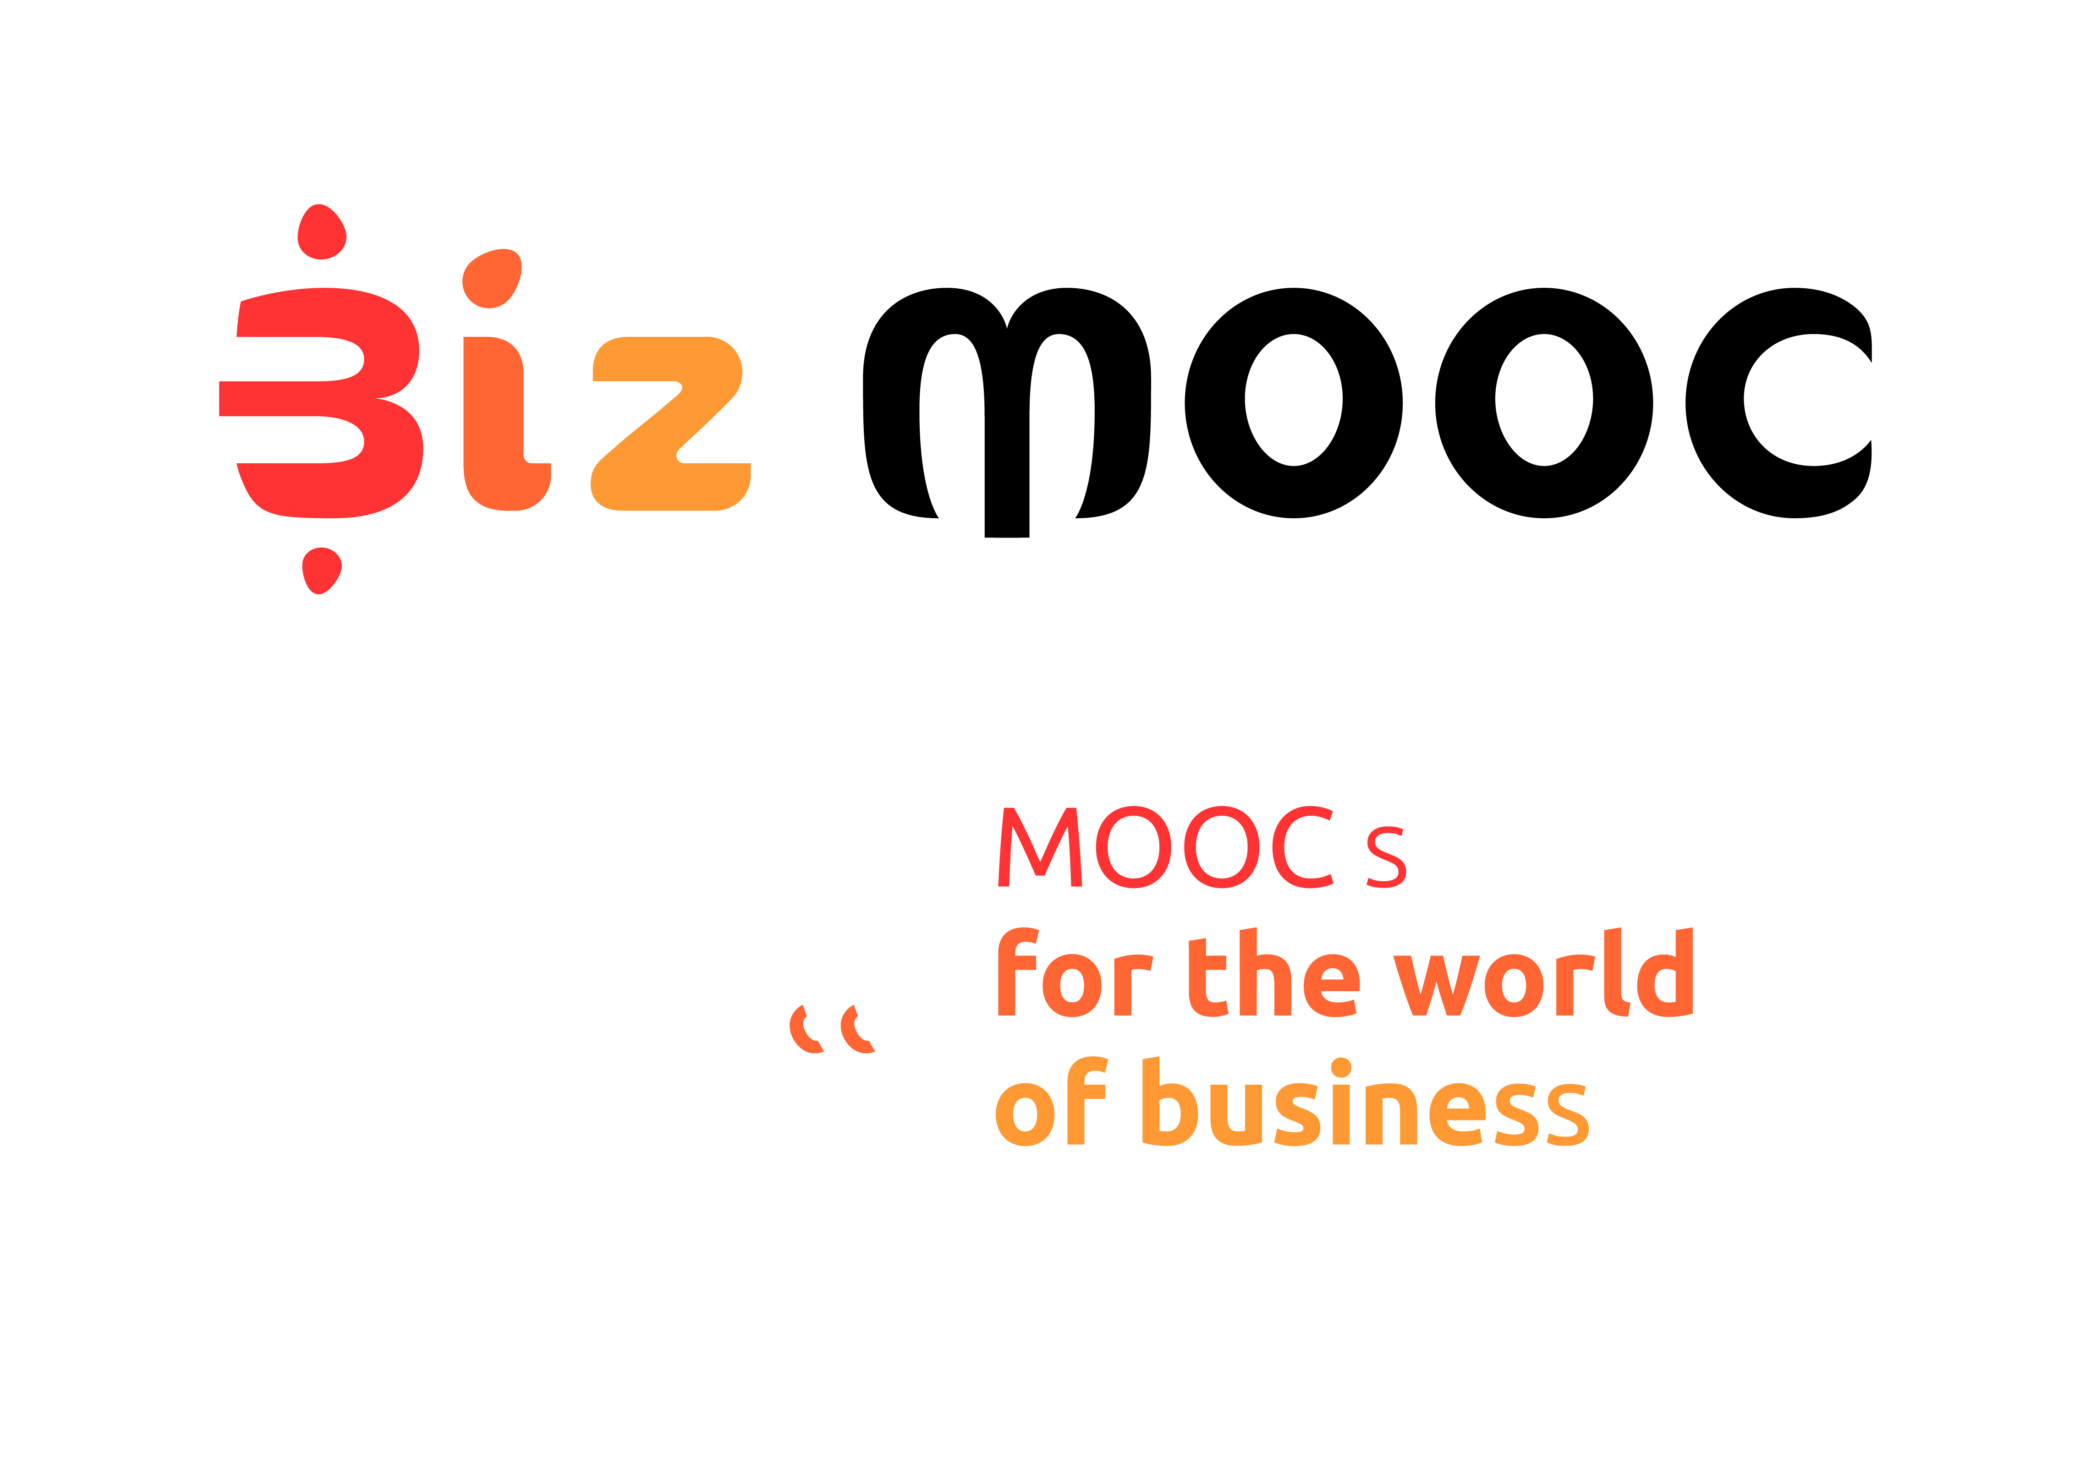
08
Fall

BizMOOC Ressources
Post-MOOC Expert Evaluation
  - Post-MOOC Expert Evaluation

BizMOOC Ressources
Post-MOOC Expert Evaluation

BizMOOC - BizMOOC - Knowledge Alliance to enable a European-wide exploitation of the potential of MOOCs for the world of business
Programme: Erasmus+ | Key Action 2 | Knowledge Alliances
Reference Number: 562286-EPP-1-2015-1-AT-EPPKA2-KA
Grant agreement number: 2015-2929 / 001-001
Project Duration: 36 months, 1/1/2016 – 31/12/2018

www.mooc-book.eu
www.bizmooc.eu

In this document, we highlight open questions used to get feedback from external experts in focus group sessions after the MOOC ended. This has a generic framework but some questions are tailored to specific aim and target group of the MOOC. We have created them for the BizMOOC project. There are general questions for all 3 Pilot MOOCs we have done and specific questions for each MOOC according to topic & specific target audience. Feel free to use, adapt, it has an open license. (CC-BY license). There are also Pre-Course MOOC Expert Evaluation questions existing on mooc-book.eu.

GENERAL QUESTIONS
- Which topics of the MOOC did you find most relevant for
  - yourself
  - your peers/target group (your employees/colleagues/students..)?
  - (optional) Why were they relevant?

- Do you see the MOOC as beneficial for your peers/target group (short-term ; long-term)?
  - If so, why? And what can be done to make the MOOC even more beneficial?
  - If not, why? What are the main challenges to overcome or is this impossible?

- What are the main barriers for your peers/target group for enrolling in this MOOC?

- Is this MOOC competitive to similar offerings to your peers/target group so far? I.e., compared to both inhouse / outsourced training and courses in classroom setting or other online courses.

- Do you see possibilities to offer this MOOC (and other MOOCs) at a large scale in both your organisation and in other organisations throughout Europe? (If so, give details....)

- What are the main issues to facilitate the wide-scale uptake of this MOOC (and other MOOCs) in business training?

ADDITIONAL OPTIONAL QUESTIONS FOR EACH MOOC TEAM (to the specific content, format, whatever)
- How would you attempt to improve this MOOC? What would be the key areas of focus?

- Have you already seen a MOOC with similar content? If so, what differences did you observe?

- What do you perceive to be the main issues affecting uptake of training and development in business?

- How can technology be used to improve business education? (invite detail)

- What message do you have for policymakers in the European area?

- According to your experience, could a course realized only in English be a limititation in your regional context? (Adaptation to the cultural/language context of the target group?)

